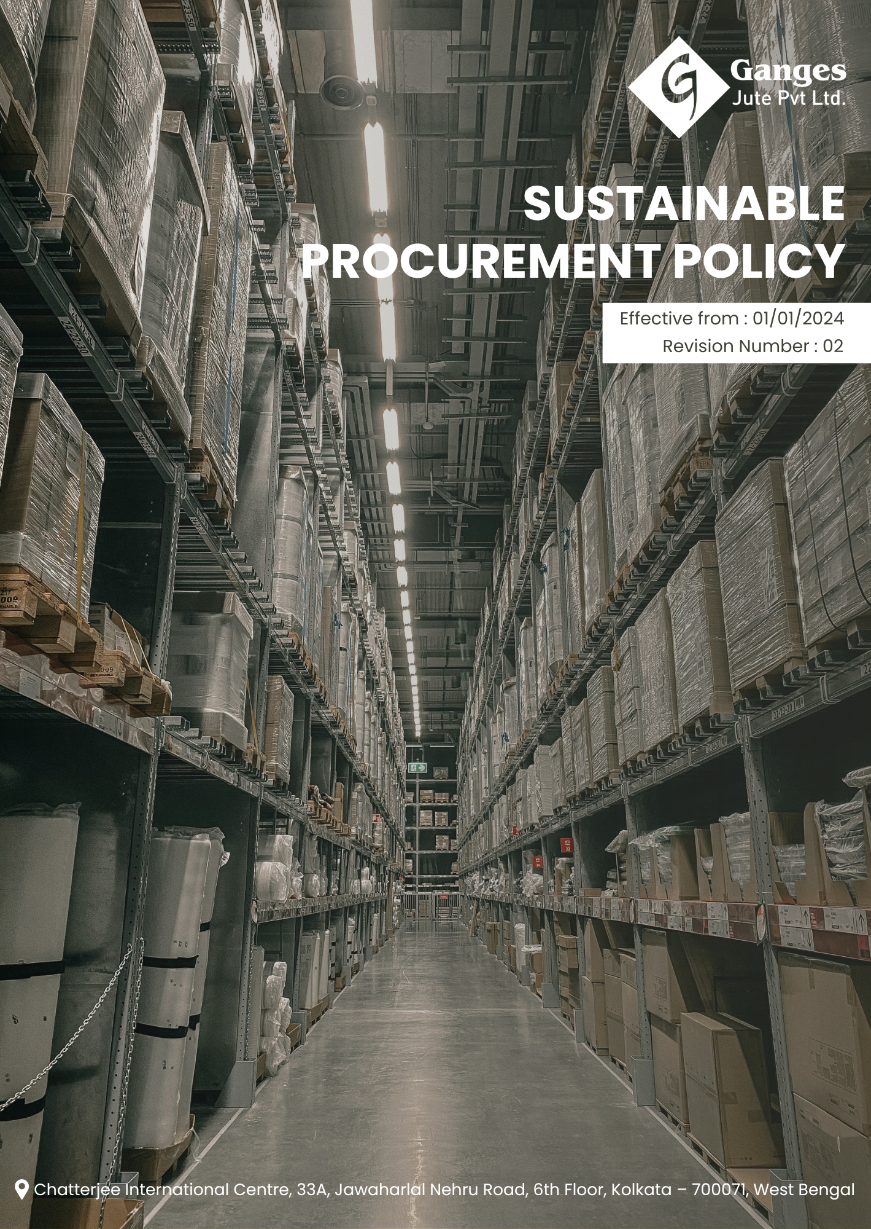

Table Of Contents

1. Why It Matters 3
2. The Ganges Jute Way 3
3. Scope 3
4. What's Expected 3
5. Jute's Journey to Sustainable Procurement Excellence: A Ganges Jute Commitment 4
6. Governance and Allocation of Responsibilities 5
7. Reporting Section 6
8. Covered SDGs 7
9. Review Mechanism 7
10. Ganges Jute Pvt Ltd - Sustainable Procurement Policy Employee Acknowledgement Form 9

Why It Matters
At Ganges Jute Pvt Ltd, we recognize that sustainable procurement practices are crucial for our long-term success and environmental stewardship. Our commitment to sustainable procurement goes beyond mere cost considerations; it is a fundamental aspect of our corporate responsibility and a key driver of our business strategy. By maintaining high standards in our procurement processes, we reduce our environmental impact, ensure ethical labor practices, build resilient supply chains, and create positive value for society.

The Ganges Jute Way
Ganges Jute Pvt Ltd is committed to implementing sustainable procurement practices throughout our supply chain. We source, manufacture, and deliver our jute products while adhering to principles of sustainability, transparency, and responsibility. Our approach encompasses environmentally friendly sourcing, fair labor practices, supplier diversity, and innovative sustainable materials.

We set annual sustainable procurement goals, develop necessary capabilities, and commit appropriate resources to achieve this policy through innovation, operational excellence, and aligning Ganges Jute's entire value chain with our sustainability standards.

Scope
This policy applies to all employees, stakeholders, contractors, partners, customers, contractual workers, and anyone acting on behalf of following sites:

 | Ganges Jute Pvt Ltd
 | Address: Bansberia, Hooghly District, West Bengal, India
 | https://gangesjute.com/

What's Expected
- Sustainable Procurement Compliance
Ganges Jute Pvt Ltd is committed to implementing sustainable procurement practices across our operations. We go beyond legal compliance and actively integrate sustainability considerations into all aspects of our procurement processes, including fostering a culture of environmental responsibility and social equity. By setting clear sustainable procurement performance standards and utilizing a comprehensive Sustainable Procurement Management System, we drive continuous improvement in areas such as Responsible Sourcing and Supplier Engagement, Circular Economy and Waste Reduction, Ethical Labor Practices in the Supply Chain, including through:
- Implementing a robust supplier evaluation system that includes sustainability criteria
- Establishing clear procedures for reporting sustainability concerns in the supply chain.
- Maintaining accurate records of our procurement practices and their environmental and social impacts.
- Implementing systems to track and reduce the carbon footprint of our procurement activities.
- Promoting the use of recycled and recyclable materials in our supply chain.
- Ensuring fair labor practices and human rights are respected throughout our supply chain.

Jute's Journey to Sustainable Procurement Excellence: A Ganges Jute Commitment
- Establishes 2022 as the Baseline year for measuring progress and achievements in our sustainability initiatives.

- General Sustainable Procurement Targets
- Ensure that 100% of strategic suppliers formally acknowledge, sign, and comply with Ganges Jute Pvt Ltd’s Supplier Code of Conduct by 2030.
- Conduct annual ESG self-assessments covering 100% of Tier-1 suppliers by 2030, to evaluate environmental, social, and ethical performance and identify improvement areas.
- Conduct on-site ESG audits for 100% of identified high-risk suppliers on an annual basis by 2035, to monitor compliance with sustainability and ethical requirements.
- Ensure that 100% of procurement employees and key suppliers receive ESG and sustainable procurement training annually by 2030, strengthening awareness and implementation of responsible sourcing practices.
- Achieve and maintain zero incidents of major supplier non-compliance related to sustainability, human rights, or ethical requirements by 2030, through effective monitoring, engagement, and corrective action mechanisms.

- Responsible Sourcing and Supplier Engagement:
- We aim to achieve 100% supplier adherence to our Sustainable Supplier Code by 2030, implementing a comprehensive supplier management platform with real-time performance tracking.
- We plan to implement a blockchain-based supply chain traceability system by 2030, capable of tracking 95% of our raw materials from source to final product.
- We intend to conduct comprehensive sustainability audits for all Tier 1 suppliers annually by 2024 with a goal of extending to Tier 2 suppliers by 2030, using AI-powered risk assessment tools.

- Circular Economy and Waste Reduction:
- We aim to achieve 60% circular material use in our products by 2030, implementing advanced recycling technologies and redesigning products for circularity.
- We plan to implement a zero-waste-to-landfill policy across our supply chain by 2030, supported by a network of certified waste management partners.
- We intend to reduce packaging waste by 40% by 2030, through innovative, eco-friendly packaging solutions, including biodegradable and compostable materials.

- Ethical Labor Practices in the Supply Chain:
- We aim to ensure 100% of suppliers comply with fair labor standards by 2030, implementing a robust monitoring system with regular third-party audits.
- We plan to implement a living wage program across our entire supply chain by 2030, collaborating with local NGOs and labor organizations to define and enforce living wage standards.
- We intend to achieve zero incidents of forced labor or child labor in our supply chain by 2030, using advanced risk assessment tools and unannounced audits.

Governance and Allocation of Responsibilities
The governance of Ganges Jute Pvt Ltd's Sustainable Procurement Policy is structured to ensure accountability and the effective execution of our sustainability objectives. Roles and responsibilities are clearly defined at all organizational levels to ensure alignment with our sustainable procurement goals. Key responsibilities are distributed as follows:
- Board of Directors:
- Oversees the overall sustainable procurement strategy and approves long-term sustainable goals.
- Approves long-term sustainability goals and ensures alignment with business objectives.
- Reviews and approves the annual Sustainable Procurement Report.

- Chief Sustainability Officer (CSO):
- Leads the development and implementation of the Sustainable Procurement Policy across the organization.
- Reports directly to the Board of Directors, providing Annually updates on sustainability performance.
- Chairs the sustainability Committee and oversees sustainable procurement program.

- Senior Management:
- Provides leadership in implementing sustainable procurement practices within their divisions.
- Allocates necessary resources and integrates sustainability metrics into performance evaluations.
- Participates in regular sustainability training and leads by example.

- Sustainability Committee:
- Comprises representatives from Procurement, Quality, R&D, Operations, and Finance
- Meets monthly to review sustainability performance, investigate reported incidents, and recommend policy improvements
- Oversees the implementation of sustainable procurement initiatives and training programs.

- Head of Procurement:
- Responsible for integrating ethical practices into all procurement activities.
- Ensure compliance with sustainable procurement standards and support sustainability training efforts.
- Conduct regular sustainability risk assessments within the procurement function.

- Supplier Relationship Manager:
- Manages supplier engagement on sustainability issues
- Conducts supplier sustainability assessments and audits
- Develops and implements supplier capacity building programs on sustainability.

- Sustainability Data Analyst:
- Collects and analyses data on sustainable procurement performance
- Prepares regular reports on key sustainability metrics
- Supports the development of sustainability targets and tracking of progress.

- Employees in Procurement:
- Adhere to the Sustainable Procurement Policy in all procurement activities
- Report any sustainability concerns through appropriate channels
- Participate in mandatory sustainability training programs annually.

Reporting Section
- Internal Reporting:
- Annual Ethics Dashboard:
- The CSO presents a comprehensive sustainability dashboard to the Board and senior management.
- The dashboard highlights key sustainability procurement indicators, progress on initiatives, and emerging trends.

- Sustainability Incident Reporting:
- A dedicated sustainability helpline is available for employees to report concerns
- All reports are logged, investigated, and resolved within 30 days, with regular updates to the Sustainability Committee.

- External Reporting:
- External reporting is conducted annually to communicate our sustainable procurement to stakeholders.
- Reports are prepared in accordance with internationally recognized standards such as the Global Reporting Initiative (GRI) guidelines or aligned with SASB industry-specific metrics.

- Stakeholder Engagement:
- Regular sustainability-focused supplier forums and workshops
- Annual stakeholder survey on sustainable procurement practices
- Participation in industry collaborations and multi-stakeholder initiatives on sustainable supply chains.

Covered SDGs
 |  | 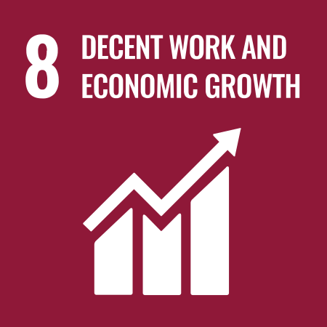 | 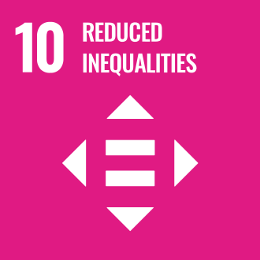 | 

Review Mechanism

- Annual Performance Review:
- An annual performance review is conducted to assess progress towards sustainable procurement goals and targets.
- Key achievements, challenges, and areas for improvement are identified through a comprehensive evaluation process.

- Continuous Improvement:
- Annual review of sustainability KPIs and adjustment of strategies as needed
- Integration of feedback from suppliers, customers, and other stakeholders
- Benchmarking against industry best practices and updating policies accordingly.

- Policy Review and Update:
- The Chief Sustainability Officer reviews this policy Every two years to ensure alignment with changing regulatory requirements, industry best practices, and stakeholder expectations.
- Updates to the policy are communicated internally, and relevant training is provided to ensure awareness and compliance.

- Revision History

Revision No. | Revision Date | Description of Change
01 | 01-01-2023 | Initial release of the Sustainable Procurement Policy
02 | 01-01-2025 | Modified sustainability targets with revised achievement timelines, added Added general sustainable procurement targets, and introduced a formal Revision History table

(Signature)
Approved By: Mr. Ahwini Kariwala
Designations: Executive Director
Last Review Date: 01-01-2025 Next Review Date: 01-01-2027

Ganges Jute Pvt Ltd - Sustainable Procurement Policy Employee Acknowledgement Form

I acknowledge that I have read and understood Ganges Jute's Sustainable Procurement Policy. I am aware of our company's commitment to responsible sourcing, waste reduction, ethical labor practices. I understand my role in supporting these initiatives and will apply sustainable procurement principles in my work.
I commit to participating in relevant training, reporting any sustainability concerns, and actively contributing to our company's sustainable procurement goals. I understand that adherence to this policy is a condition of my employment, and I will seek guidance from my supervisor or the Sustainability Team if I have any questions about implementing sustainable practices in my role.
Employee Name: ______________________
Employee Signature: ______________________
Date: __________________

